**Software Design Specification**

**Bilingual AI Virtual News Anchor**

Project Code:

To Be Assigned  
Internal Advisor:

Prof. Farooq Javed  
Project Manager:

Dr. Muhammad Ilyas  
Project Team:

Mohsin Ali (TL) – Roll No: BSCS51F21S083

Saim Sikandar – Roll No: BSCS51F21S101

Abdul Samad – Roll No: BSCS51F20S050

Submission Date:

December 20, 2024

**Document Information**

| Category | Information |
| --- | --- |
| Customer | General public, News Agencies. |
| Project | Bilingual AI Virtual News Anchor |
| Document | Requirement Specifications |
| Document Version | 1.0 |
| Identifier | N/A-2024-N/A |
| Status | Draft |
| Author(s) | Mohsin Ali, Saim Sikandar, Abdul Samad |
| Approver(s) | Dr. Muhammed Ilyas (PM) |
| Issue Date | Nov. 29, 2024 |
| Document Location |  |
| Distribution | 1. Advisor 2. PM 3. Project Office |

**Definition of Terms, Acronyms, and Abbreviations**

| Term | Description |
| --- | --- |
| TTS | Text-to-Speech |
| API | Application Program Interface |
| Avatar | A virtual character used for video-based news presentation |

**Table of Contents**

1. Introduction

1.1 Purpose of Document 4

1.2 Project Overview 4

1.3 Scope 4

2. Design Consideration

2.1 Assumption and Dependencies 4

2.2 Risks and Volatile Areas 4

3. System Architecture

3.1 System level Architecture 5

3.2 Sub-Systems / Component / Module level Architecture 5

3.3 Sub-Component / Sub-Module Level Architecture 5

1. Design Strategies

4.1 Strategy Details 5

5. Detail System Design 6

6. References 7

7. **Appendices 8**

**1. Introduction**

**1.1 Purpose of Document**

This document outlines the design specifications for the "Bilingual AI Virtual News Anchor." It is intended for developers, stakeholders, and the project team. The document uses an object-oriented design methodology to ensure a scalable, maintainable, and efficient system.

**1.2 Project Overview**

The system is an AI-powered virtual news anchor delivering news in English and Urdu, with:

* Real-time news fetching using APIs or web scraping.
* Bilingual audio conversion using Text-to-Speech (TTS) systems.
* Presentation via a customizable 3D avatar with accurate lip-syncing.

**1.3 Scope**

The system will:

* Fetch and categorize real-time news.
* Convert text to natural audio in English and Urdu.
* Present news via a 3D avatar.
* Be desktop-compatible with future plans for cloud scalability.

**2. Design Considerations**

**2.1 Assumptions and Dependencies**

* Dependence on APIs for news retrieval and TTS conversion.
* Use of open-source tools (e.g., Coqui TTS, Three.js).
* Stable internet connection for real-time functionality.

**2.2 Risks and Volatile Areas**

* API changes could disrupt real-time news retrieval.
* Scalability challenges with increased user demand.
* Cultural and linguistic accuracy risks in bilingual news delivery.

**3. System Architecture**

**3.1 System Level Architecture**

The system comprises three primary components:

1. **News Fetching Module**: Retrieves real-time news using APIs and web scraping.
2. **TTS Module**: Converts news text into audio in English and Urdu.
3. **Avatar Presentation Module**: Animates a 3D avatar for news delivery.

**3.2 Sub-System / Component / Module Level Architecture**

* **News Fetching**:
  + APIs: NewsAPI, BeautifulSoup.
* **TTS**:
  + Tools: Coqui TTS, Google TTS.
* **Avatar Presentation**:
  + Tools: Blender, Three.js.

**3.3 Sub-Component / Sub-Module Level Architecture**

* Sub-modules for news categorization, lip-sync synchronization, and UI/UX design.

**4. Design Strategies**

**4.1 Strategy Details**

* Use modular architecture for scalability.
* Leverage open-source tools to minimize costs.
* Ensure a user-friendly interface with accessibility features.

**5. Detailed System Design**

* **Class Diagrams**: Detailed classes for modules and their interactions.
* **Sequence Diagrams**: Depict workflows for news fetching, TTS conversion, and avatar animation.
* **State Transition Diagrams**: Outline system states during news delivery.
* **Logical Data Models**: Entity-Relationship diagrams for data management.
* **GUIs**: Mockups of user interfaces for desktop platforms.

**7. References**

| Ref. No. | Document Title | Date of Release/ Publication | Document Source |
| --- | --- | --- | --- |
| 2024-Proposal | Project Proposal | Nov 29, 2024 | N/A |
| BK01-2021-AI | Artificial Intelligence: A Modern Approach | 2021 | [Artificial Intelligence: A Modern Approach, 4th US ed.](https://aima.cs.berkeley.edu/) |
| BK02-2016-DL | Deep Learning | 2016 | [Deep Learning](https://mitpress.mit.edu/9780262035613/deep-learning/) |
| JR01-2023-EUDL | The Role of AI Digital Anchors in Enhancing the News Broadcasting User Experience | 2023 | [eai.23-11-2023.2343240](https://eudl.eu/pdf/10.4108/eai.23-11-2023.2343240) |
| JR02-2023-MDPI | Understanding the Continuance Intention for Artificial Intelligence News Anchor | 2023 | [Understanding the Continuance Intention for Artificial Intelligence News Anchor: Based on the Expectation Confirmation Theory](https://www.mdpi.com/2079-8954/11/9/438) |
| JR03-2023-Semantic | The Making of an AI News Anchor—and its Implications | 2023 | [The making of an AI news anchor—and its implications | PNAS](https://www.pnas.org/doi/10.1073/pnas.2315678121) |
| WEB01-2024-DID | D-ID Creative Reality Studio | Ongoing | [D-ID's Creative Reality™ Studio | Generative AI Video Creator](https://www.d-id.com/creative-reality-studio?form=MG0AV3) |
| WEB02-2024-BeautifulSoup | BeautifulSoup Documentation | Ongoing | [Beautiful Soup Documentation — Beautiful Soup 4.12.0 documentation](https://www.crummy.com/software/BeautifulSoup/bs4/doc/?form=MG0AV3) |
| WEB03-2024-Scrapy | Scrapy Documentation | Ongoing | [Scrapy 2.12 documentation — Scrapy 2.12.0 documentation](https://docs.scrapy.org/en/latest/?form=MG0AV3) |
| WEB04-2024-GoogleTTS | Google Cloud Text-to-Speech API Documentation | Ongoing | [Text-to-Speech documentation  |  Cloud Text-to-Speech API  |  Google Cloud](https://cloud.google.com/text-to-speech/docs?form=MG0AV3) |

**8. Appendices**

**Appendix A: Architecture Diagram**

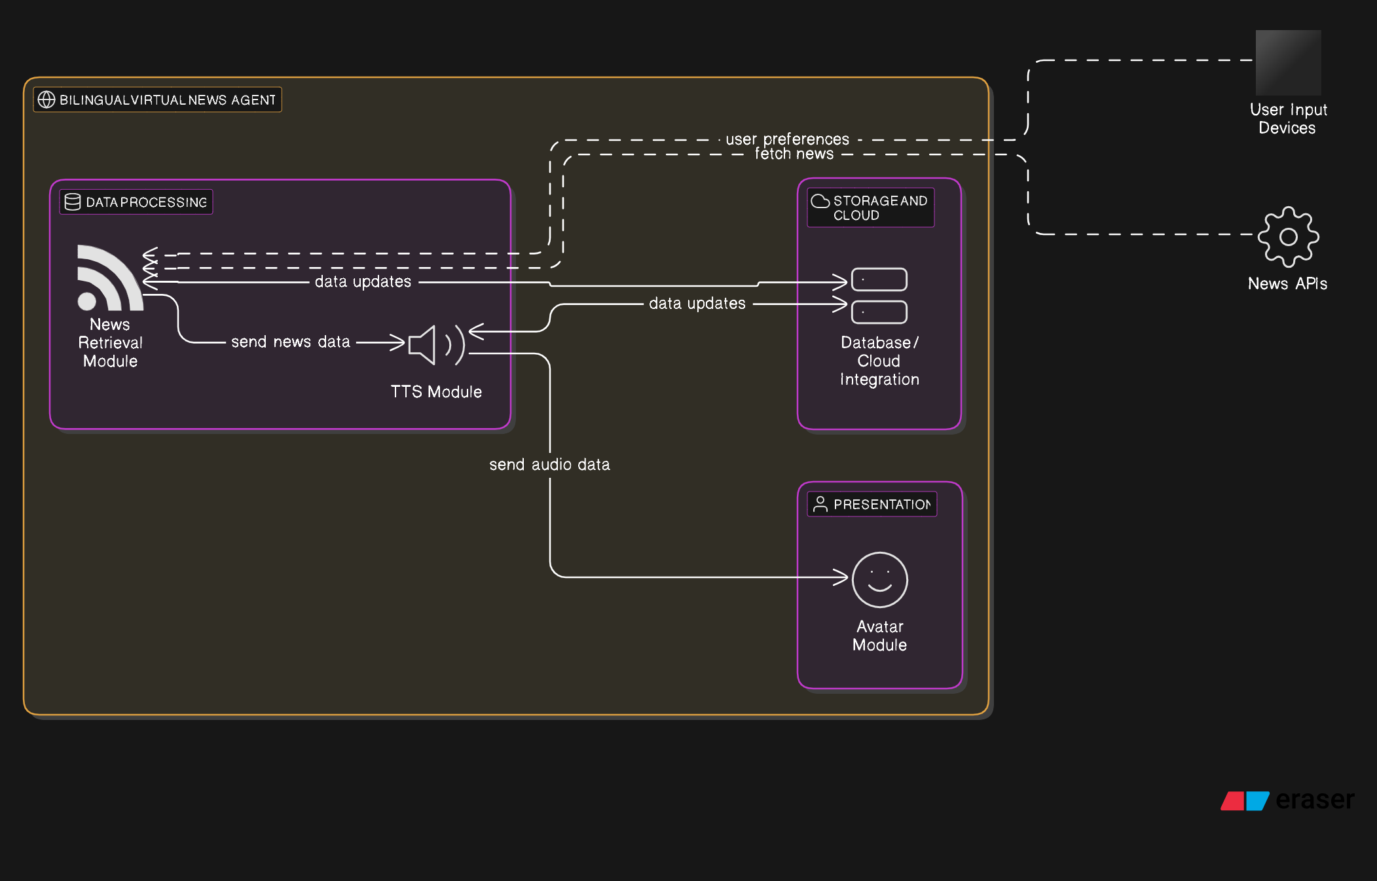

**Appendix B: Data Flow Diagram**

